Serverless automated movement of files based on filename
Below is the architecture diagram for serverless movement of files based on filename.
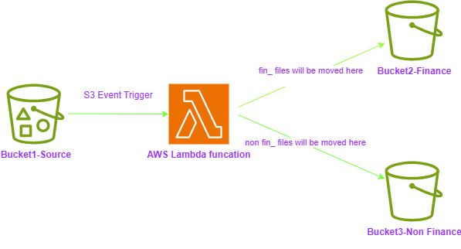
OBJECTIVE: SERVERLESS FILE MOVEMENT BASED ON FILENAMES
STEP1:
Create three S3 buckets as below
SOURCE - bucket1-source0302
DESTINATION 1 - bucket2-fin-files
DESTINATION 2 - bucket3-other-files

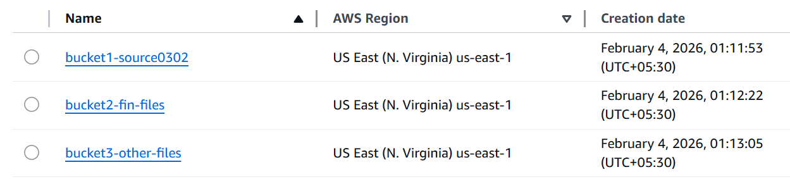
STEP 2:
IAM
Role - "LambdaS3FileRouterRole-0302" - Permissions - Inline Policy with below Json code
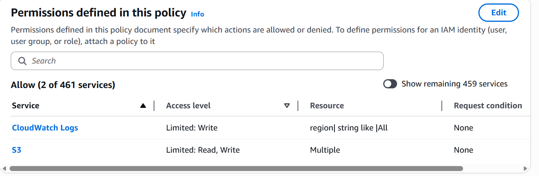

This Policy has two parts.
CloudWatchLogs - to create the logs for the creation of an object.
S3 – Read / Write operations are performed in the subject buckets. (Inline Policy)

STEP 3:
LAMBDA FUNCTION - S3-MoveFiles
In the below code, whenever the file arrives and the filename contains "fin", it is copied to the destination bucket "bucket2-fin-files" and delete from the source bucket, otherwise copy the file to Destination Bucket "bucket3-other-files" and delete from the source.

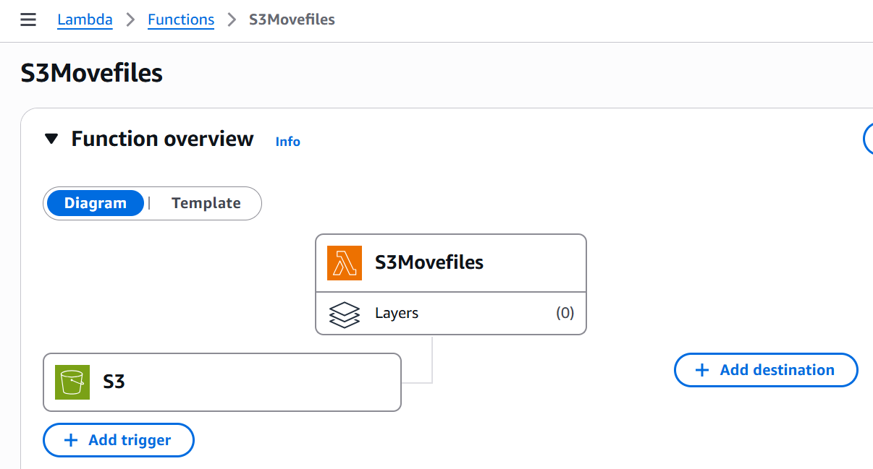
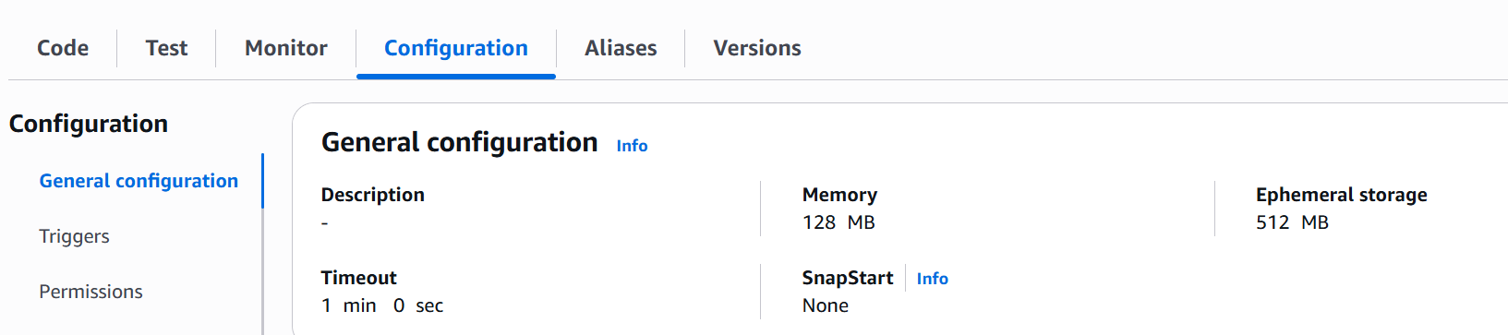

#####################################################################
STEP 4:
On the source bucket "bucket1-source0302" properties create an "event notification" for "all the object create" operations. Upon this event from the logs, it will trigger the above Lambda function.
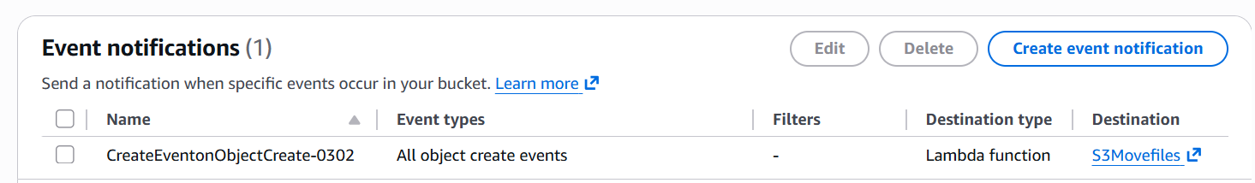
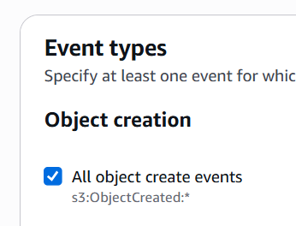
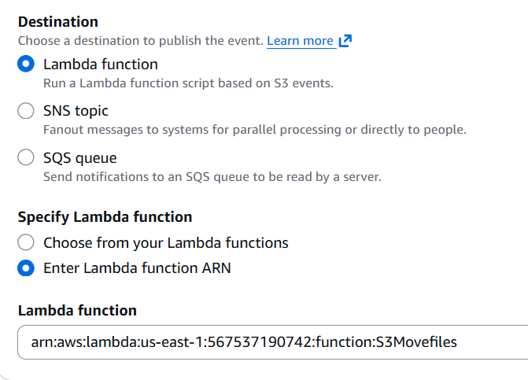
STEP 5:
For test purpose, few files containing "fin" and otherwise have been uploaded to the source folder. The serverless Lambda function successfully moved the files to the respective folder as per the given condition.
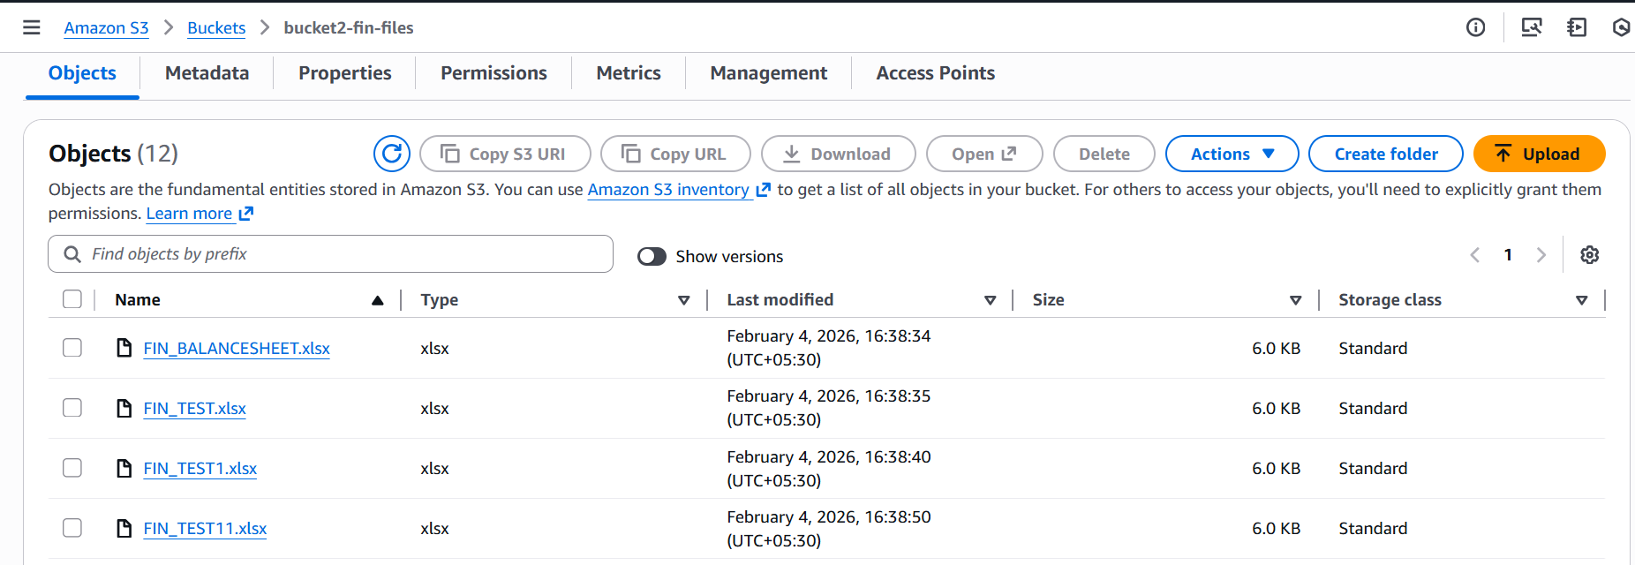
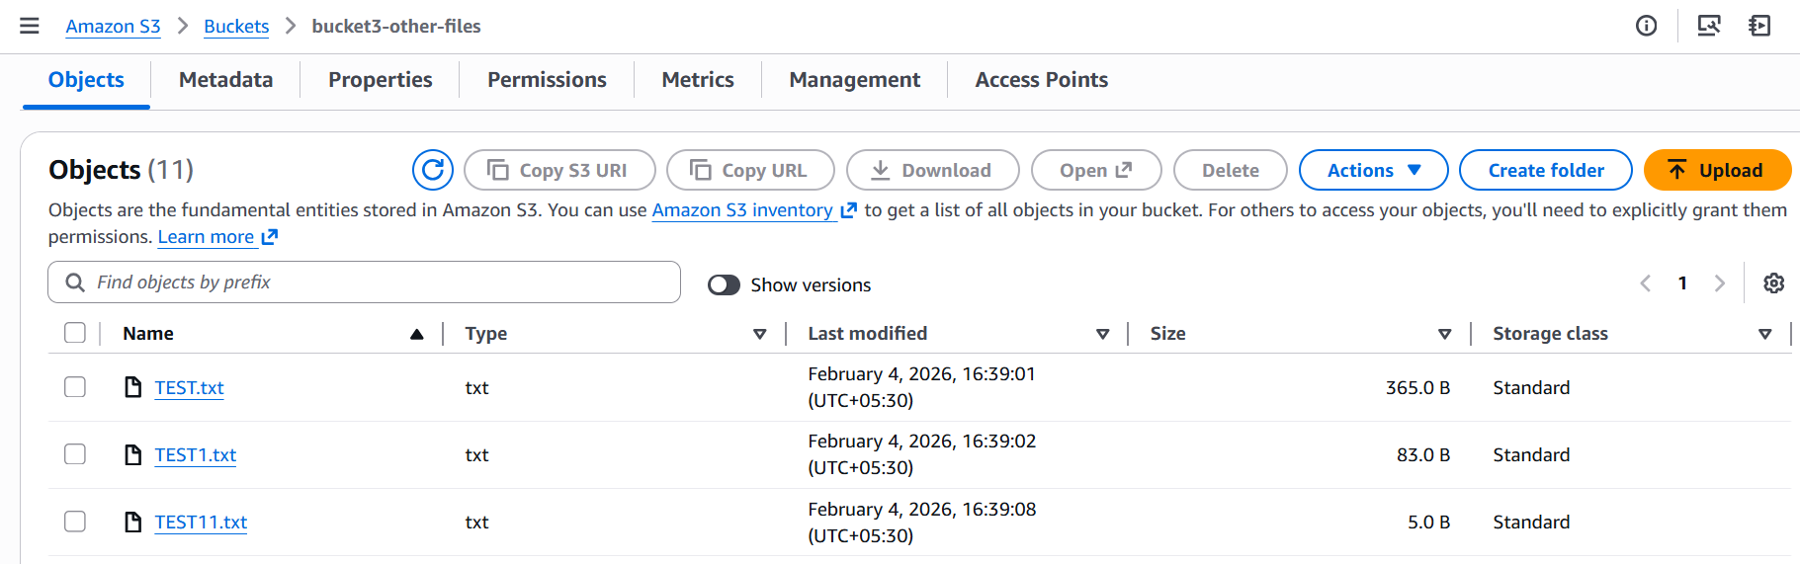

Hence, the objective achieved.
AWS services used –
IAM – Role with inline policy for permissions
S3 – Buckets for the project, Event Notification for the PUT operation on source bucket which invokes the Lambda function.
Lambda – Function, Code, Permissions, Memory, Time for execution
CloudWatchLogs – Create logs on the files created on the source bucket.

